AIX – NIM install from mksysb

**DOCUMENT HISTORY**

|  |  |  |  |  |
| --- | --- | --- | --- | --- |
| Version | Date | Name | Version purpose | Status |
| 1.0 | 09/13/2019 | Jonathan REY-GORREZ | Initial version | V |

Status: **W** = Writing in progress, **C** = for Comment, **A** = for **A**pproval, **V** = Validated, **O** = Obsolete

**DOCUMENT VALIDATION**

|  |  |  |  |
| --- | --- | --- | --- |
| Action | Date | Name | Role |
| Writing | 09/13/2019 | Jonathan REY-GORREZ | Technical Referent |
| Control | 00/00/00 | Name | Role |
| Validation | 00/00/00 | Name | Role |

Table of content

1 Overview 3

2 Pre-steps 4

2.1 Run the prep scripts 4

2.2 Take the mksysb 4

3 NIM install 5

3.1 Create the client 5

3.2 Setup the client for installation 10

3.3 Complete the installation 12

4 Post-steps 31

4.1 Crontabs 31

4.2 Filesystems 31

# Overview

The purpose of this document is to go through the installation process of a new AIX virtual server, cloned from another server’s mksysb image.

All new server creation must be validated between SDM/Technical Referent and Arkema, and there must be a ServiceNow ticket associated.

The examples used in this procedure are a mix of the following:

* Rebuild of the PGT DR environment - APHILDR110H from APHILUM110H
* New server build - APHILUM306H (CB6) from APHILUM114H (PRD)

# Pre-steps

## Scripts

From the PRODUCTION server, run the prep scripts needed to recreate the filesystems on the NEW server – for each VGs except rootvg:

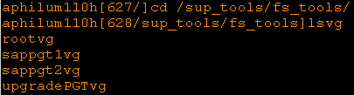





## mksysb

From the NIM server take a mksysb of the PRODUCTION server:

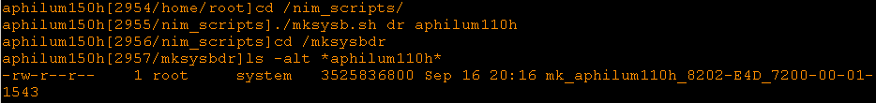

# NIM install

## Create the client

Add IP address and hostname of the NEW server to /etc/hosts on the NIM server:



Create the NEW client:







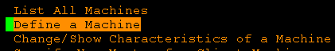

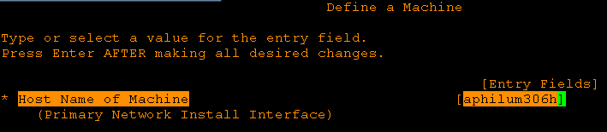

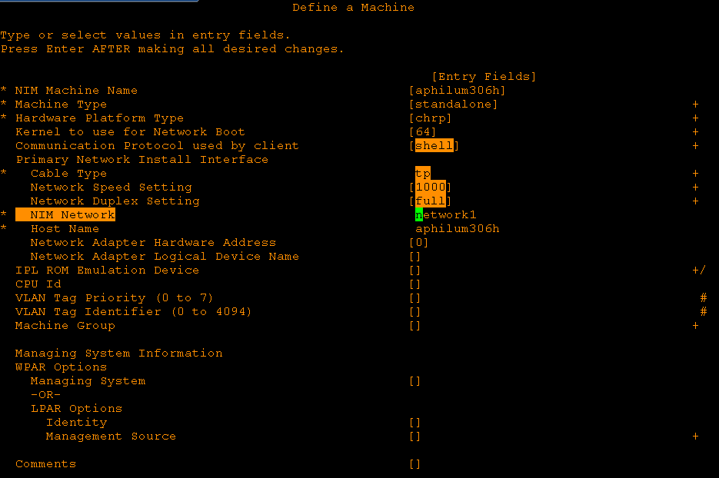

From the HMC, boot the server in SMS mode:

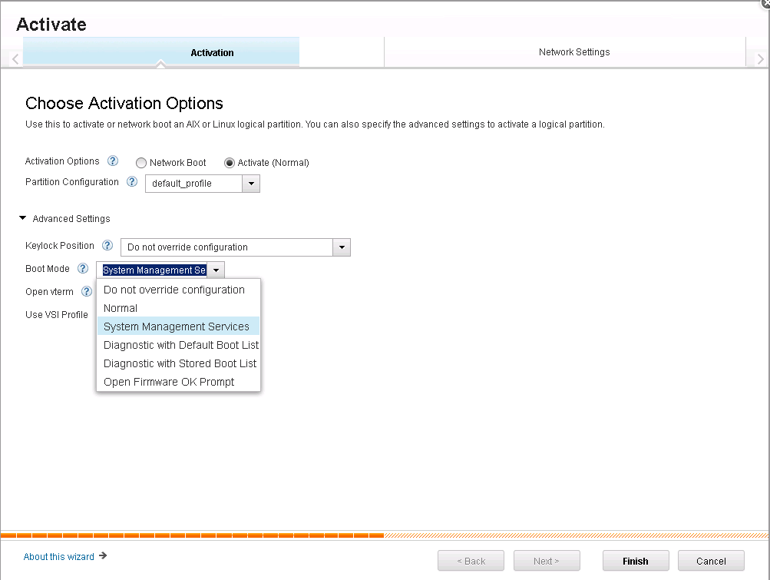

SSH to the HMC and open the console:



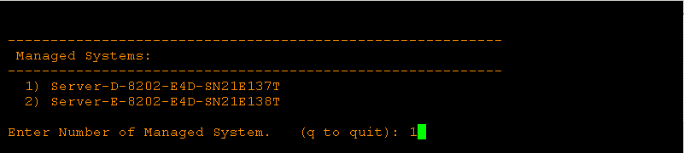

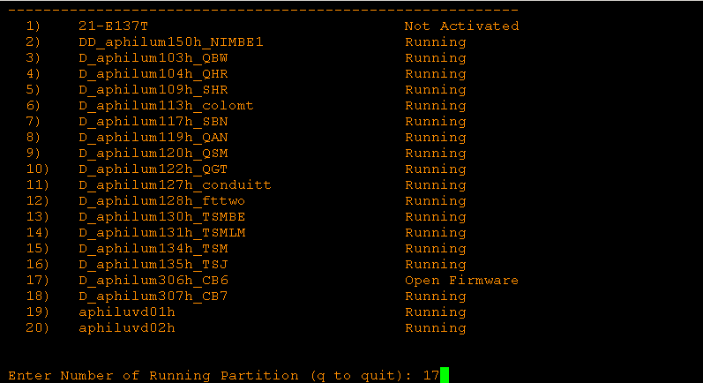

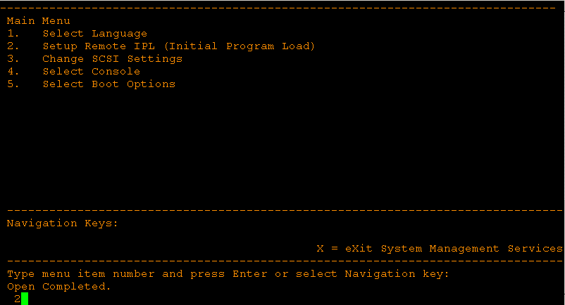

Take note of the Hardware Address – refer to the NETWORK DOC to know what adapter to choose.

Note that we use VIOS2 as default, so we’ll select either ent1 (NIC#2) or ent5 (NIC#6)

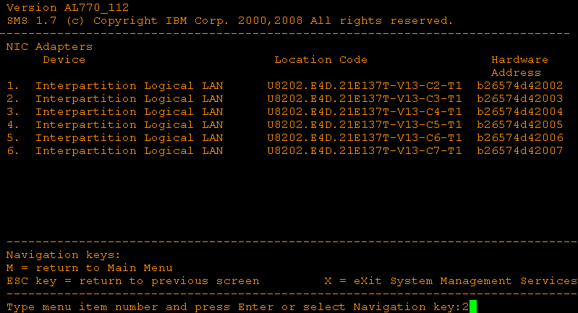

On the NIM server, edit the configuration of the new client:

Run “smit nim”





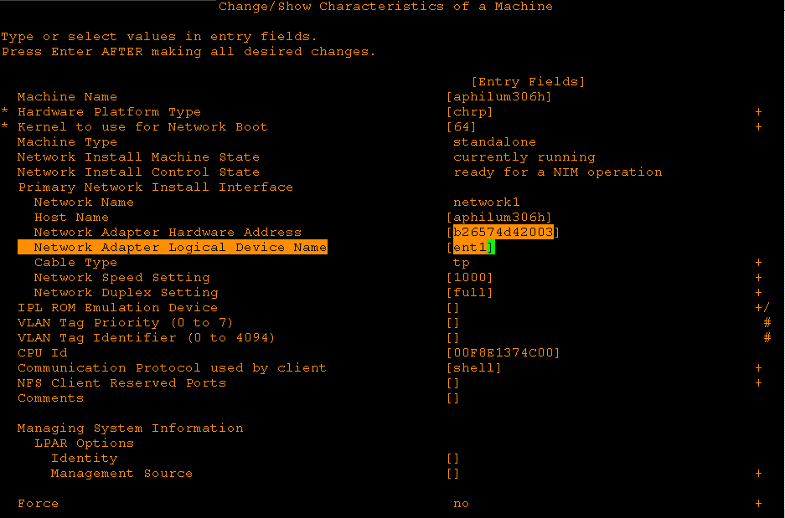

Double check the configuration with the lsnim command:

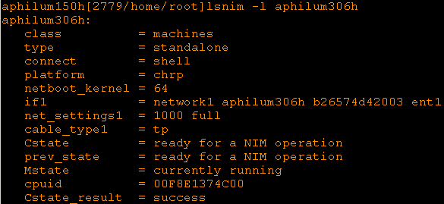

## Setup the client for installation

From the NIM server, allocate a SPOT (should be the 7.2 one) and a MK (the one of the server we want to copy the system from) resource to the new client:







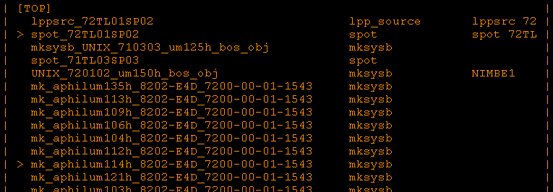

From the NIM server, prepare the new client for installation:





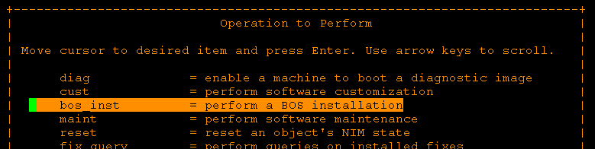

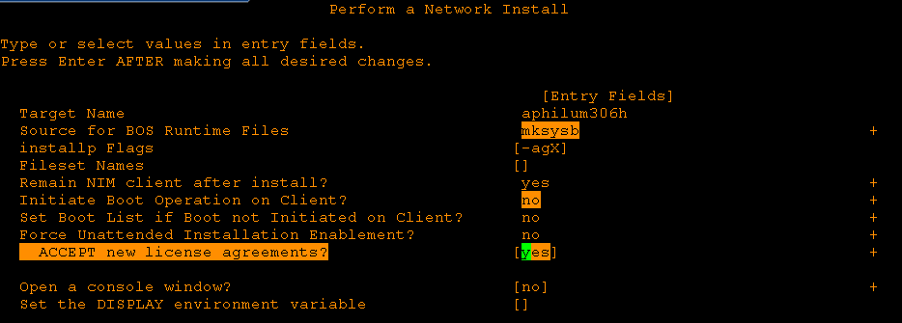

**Note: There will be options to select from menu like “Source for BIOS Runtime Files”, please press “Esc” and “4” it will show the selction menu**

Double check the NIM configuration (spot, mksysb, Cstate…) before starting the install:

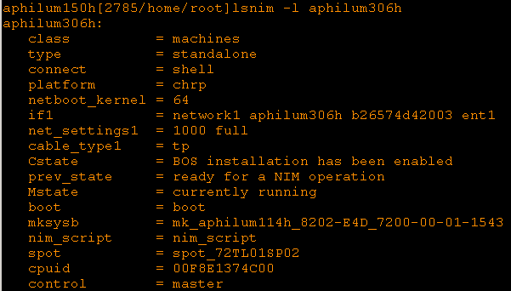

## Complete the installation

Boot the server in SMS mode, then proceed with the installation from the console.

Look at the number next to the green cursor on the bottom right of the screens to know what options to choose

Select the language:

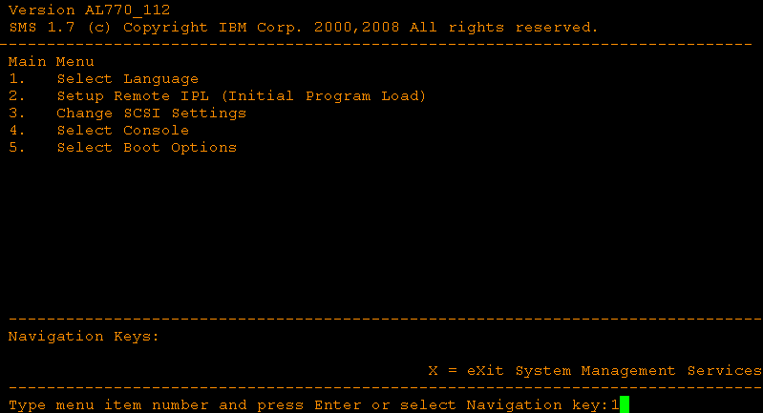

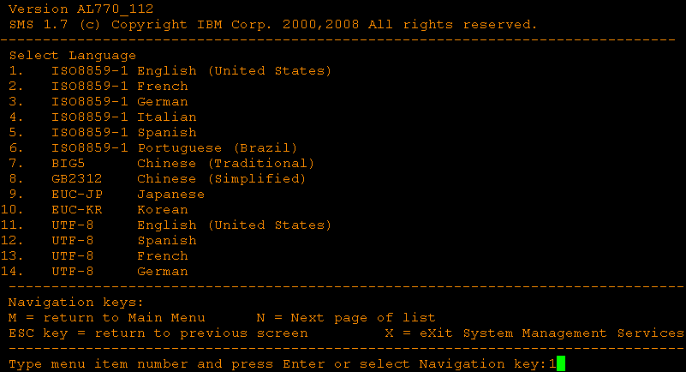

Configure the network:

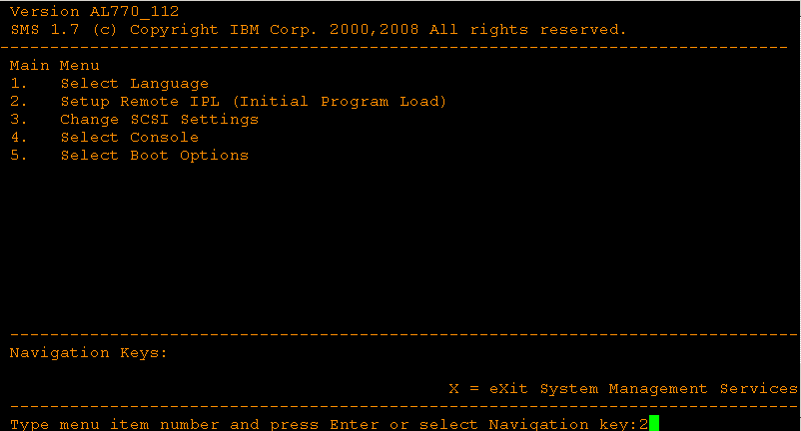

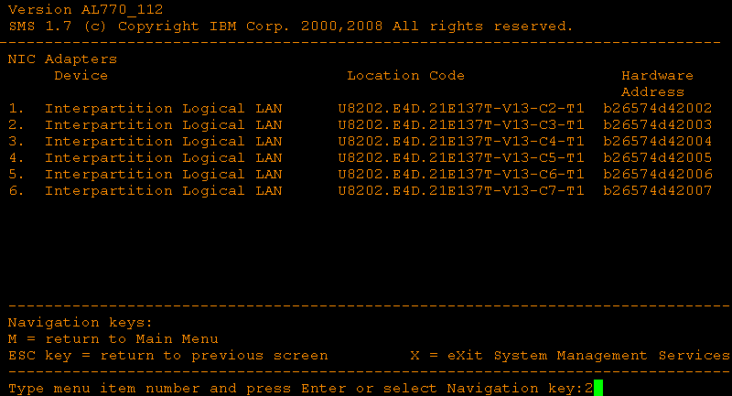

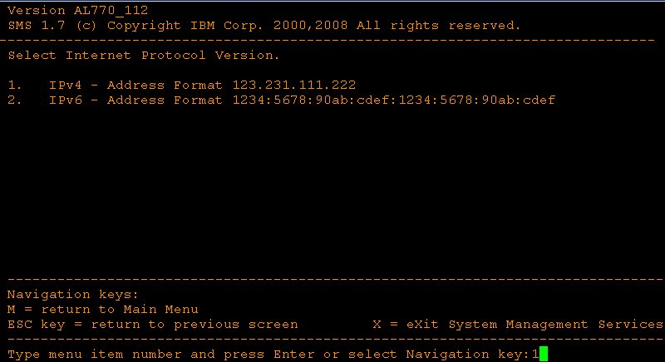

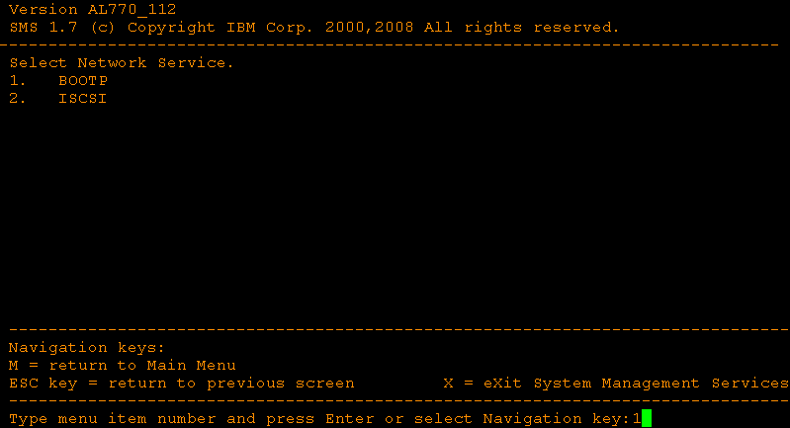

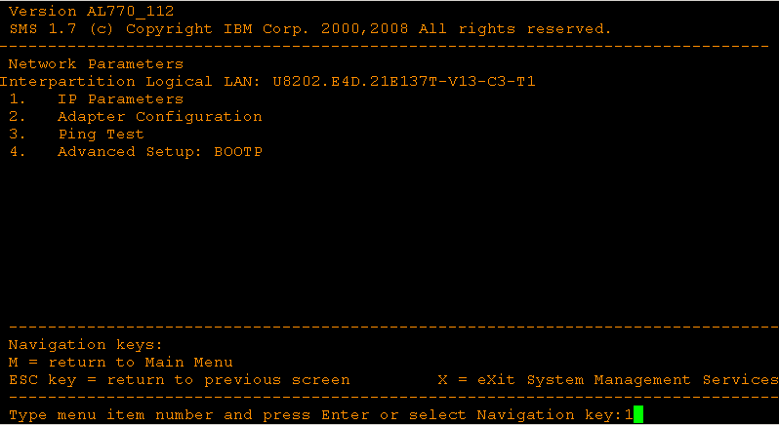

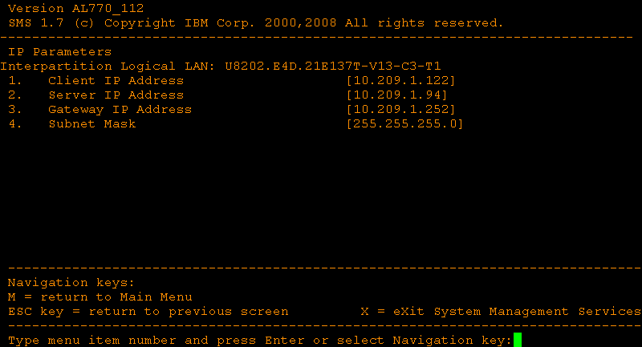

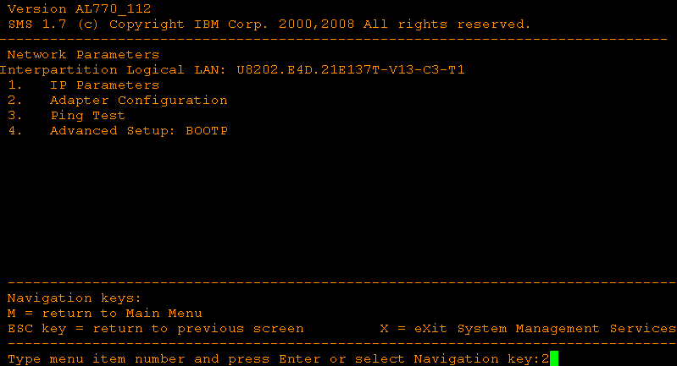

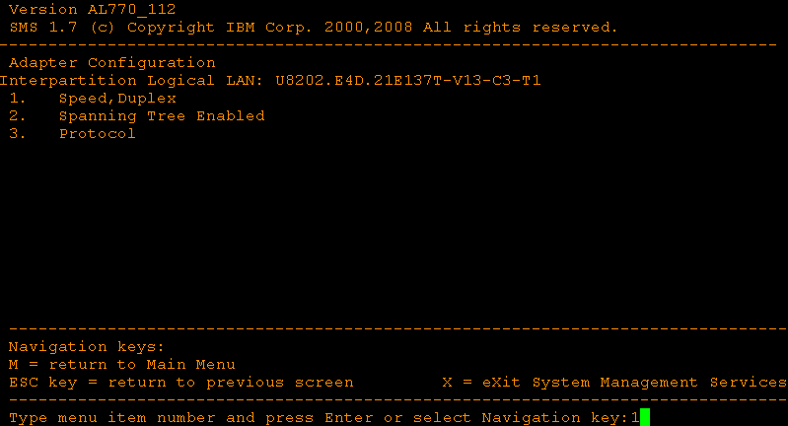

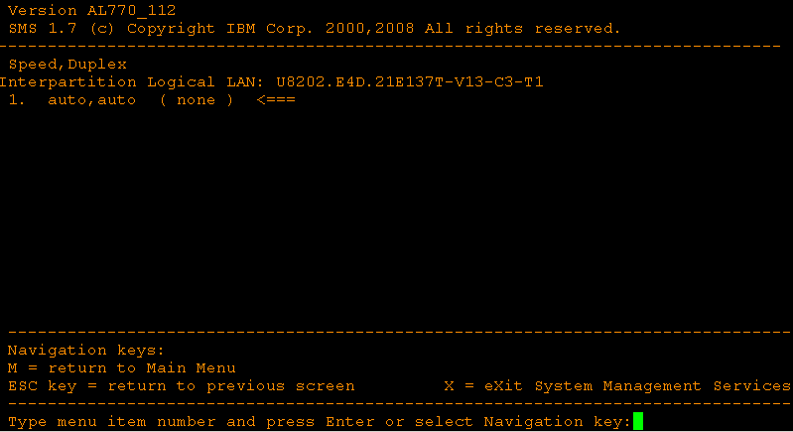

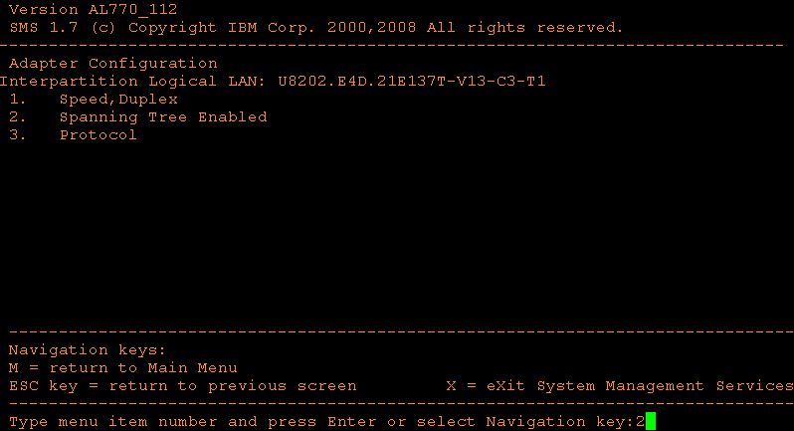

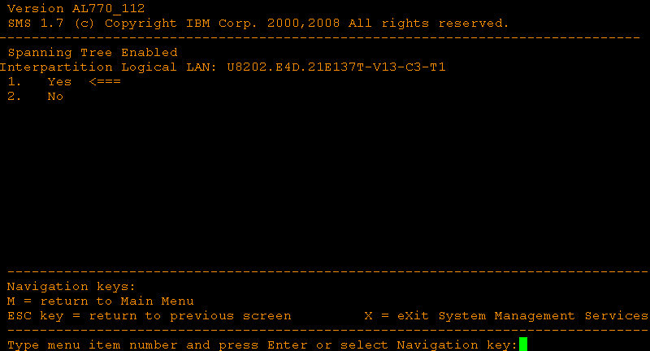

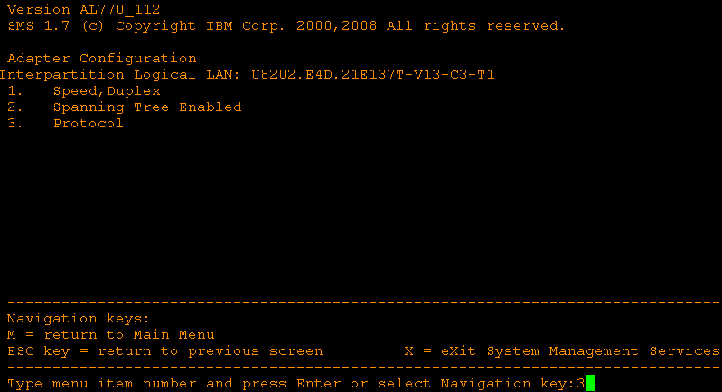

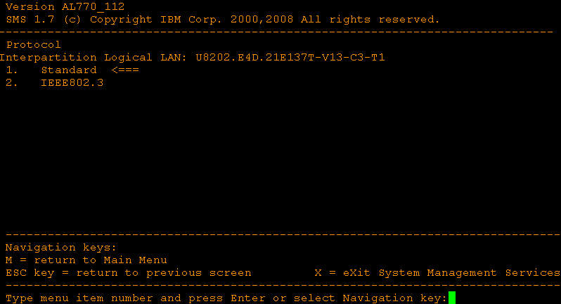

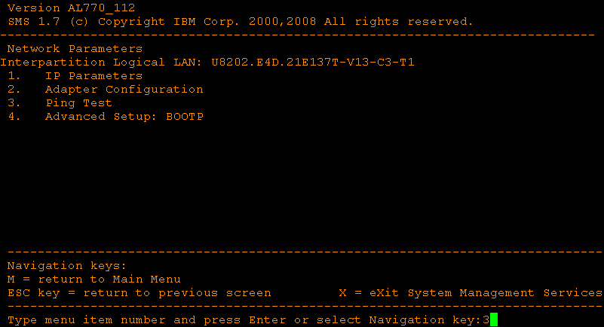

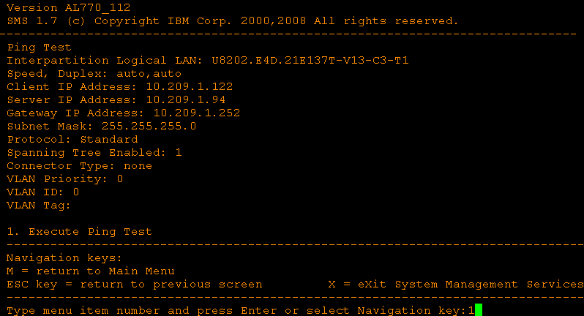

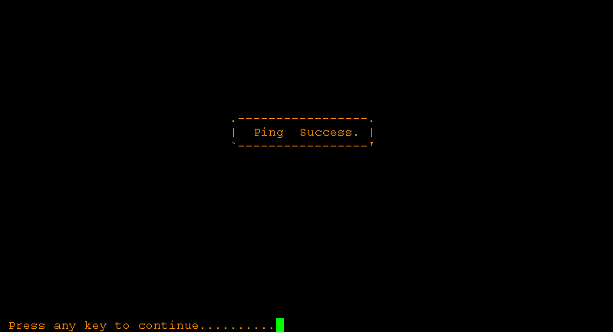

Setup the boot options:

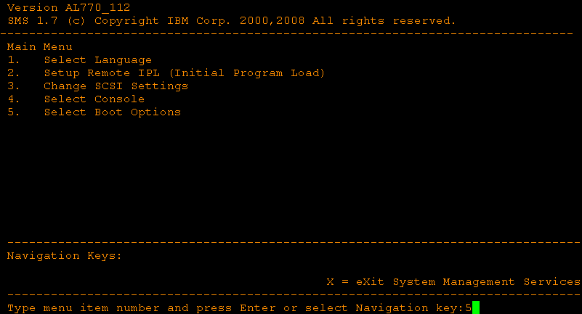

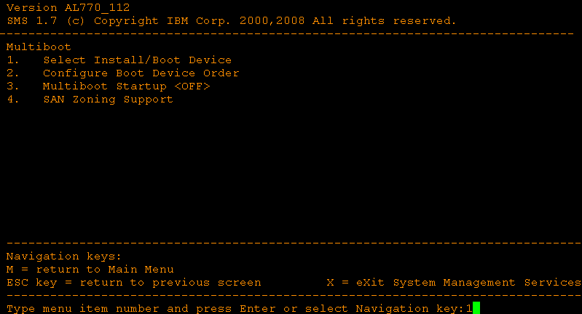

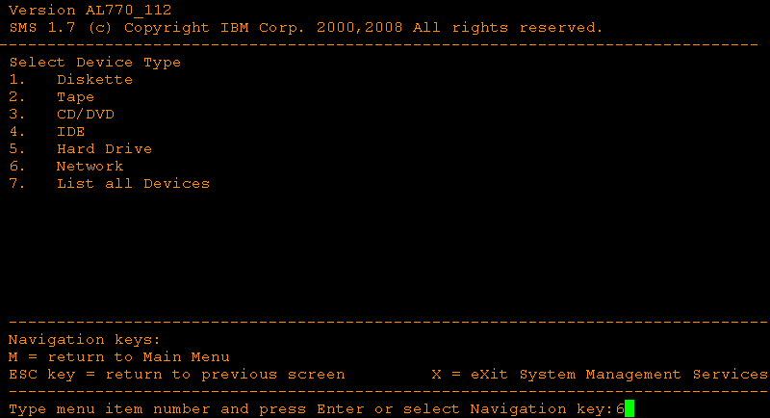

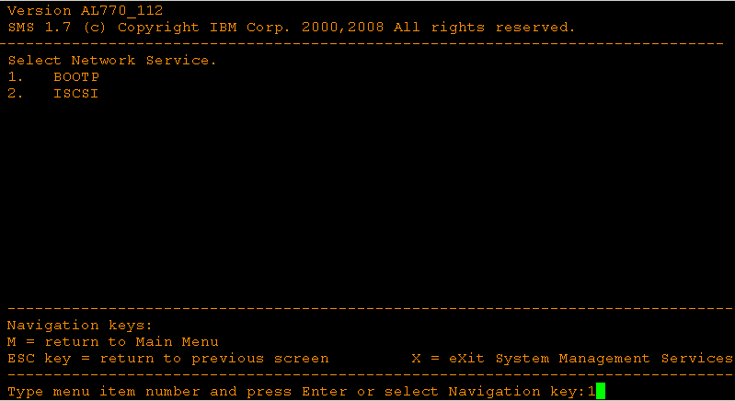

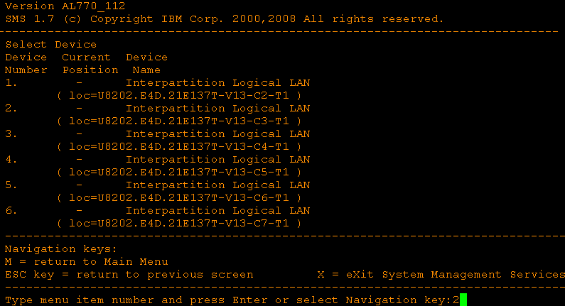

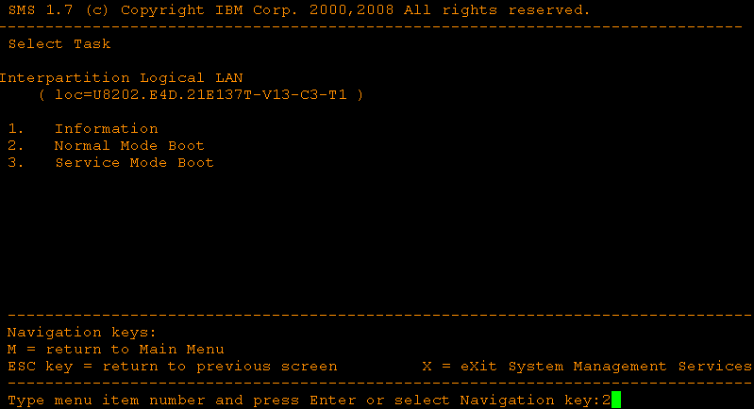

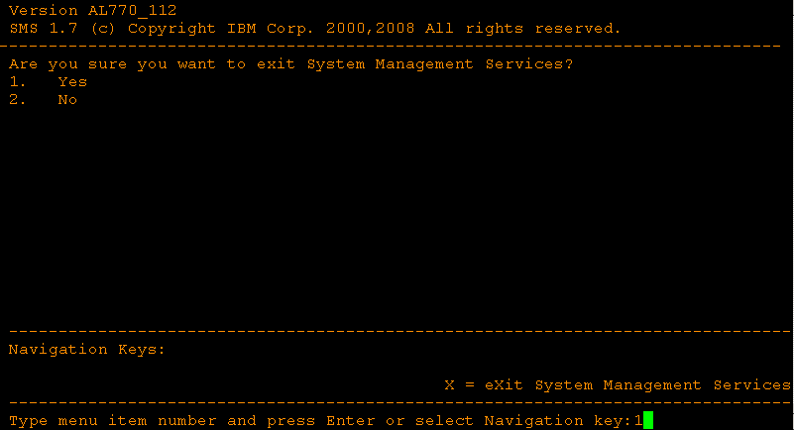

Start the install:

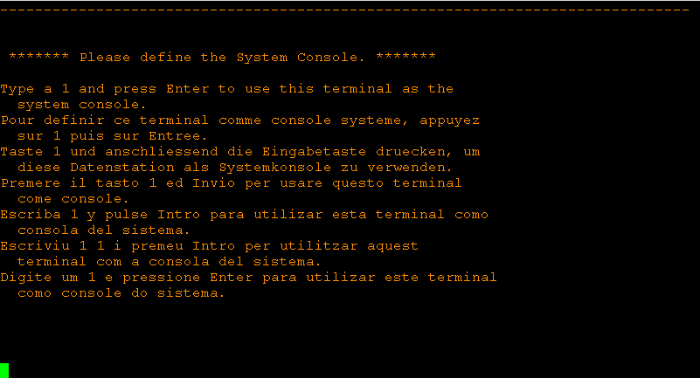

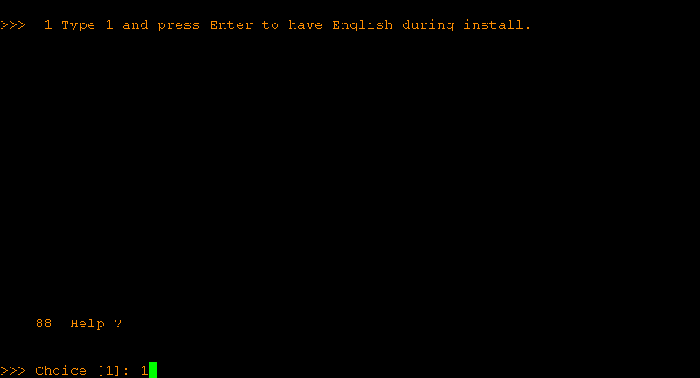

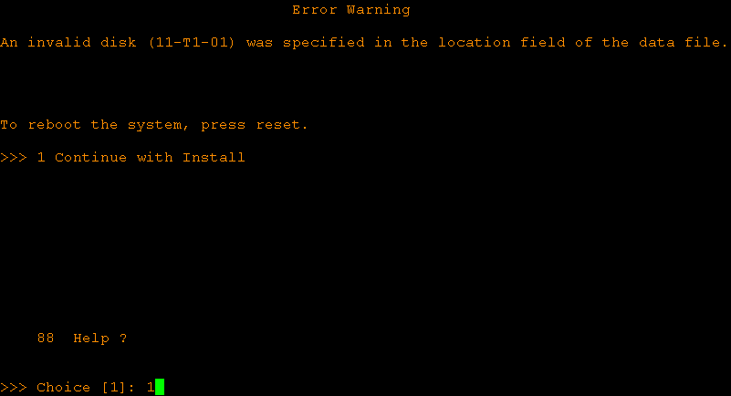

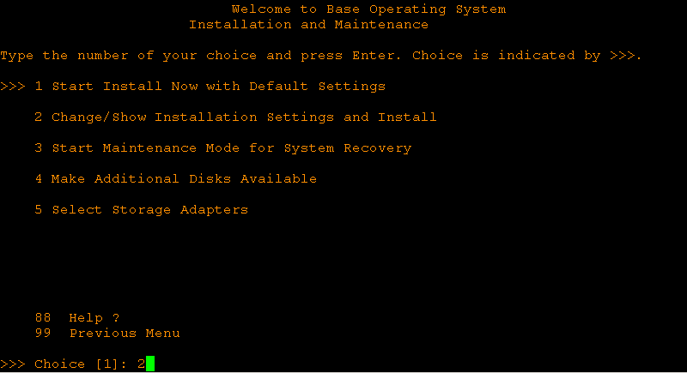

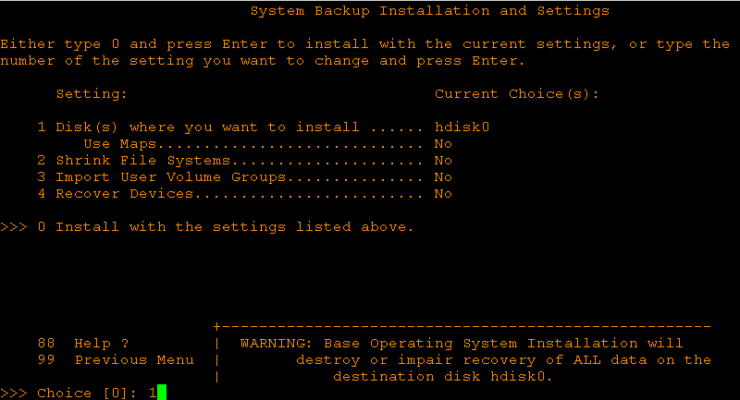

Make sure to choose the disk that is **140GB**:

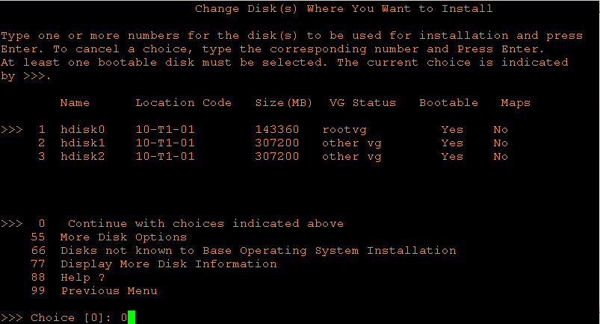

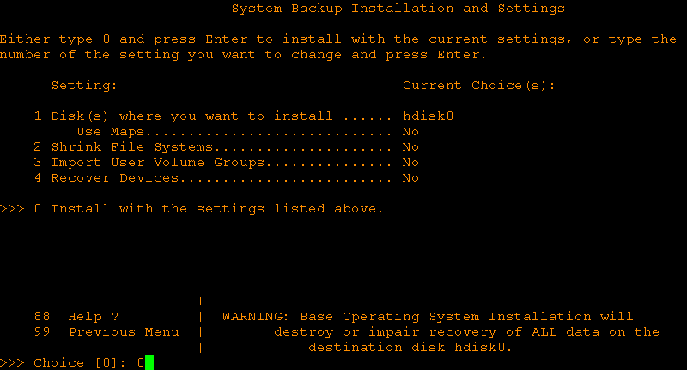

Follow the installation process from the console and/or with the lsnim command from the NIM server:

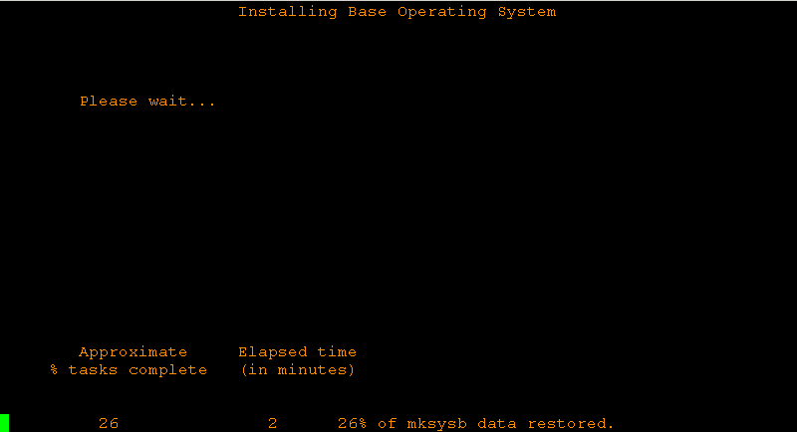

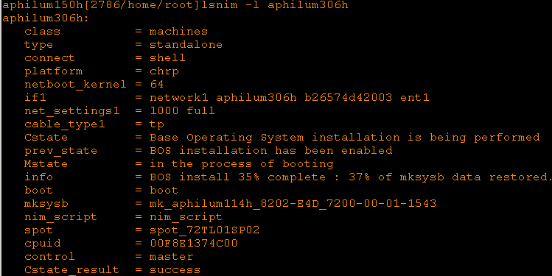

The installation is now complete:

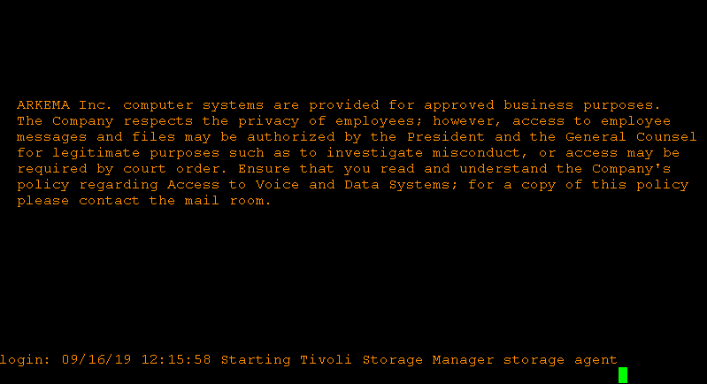

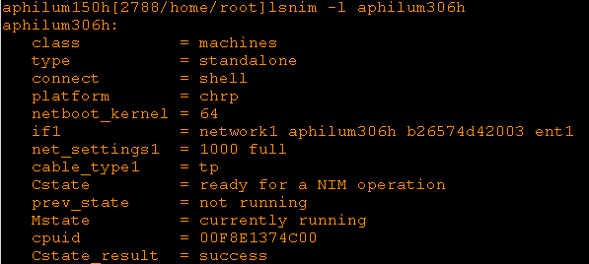

# Post-steps

## Crontabs

Go to /var/spool/cron/crontabs:

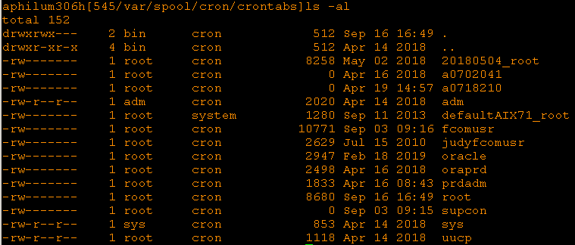

Backup the root crontab and replace it with the default one:



Empty all the user crontab entries:

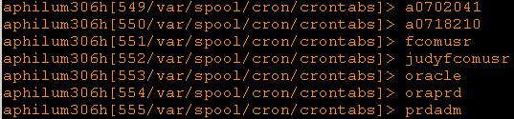

## Network

Edit the DNS and NTP config files to match the location the NEW server is in.

As a reminder:

Valley Forge 10.209.1.206

Bethlehem 10.209.1.210

Change the DNS configuration:



Change the NTP configuration:

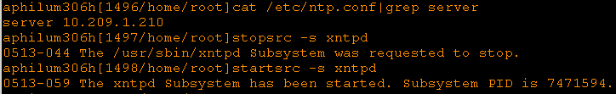

Enable the I/O completion ports:







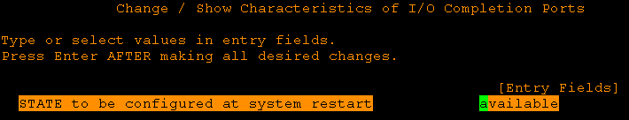



Restart the server:



## Users

Change the root password:

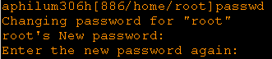

If needed – Delete the old *sidadm* user and recreate a new one with the correct SID.

Check the *sidadm* user on the PRODUCTION server to create the new user with the same parameters.

Note that the users’ name and id are unique





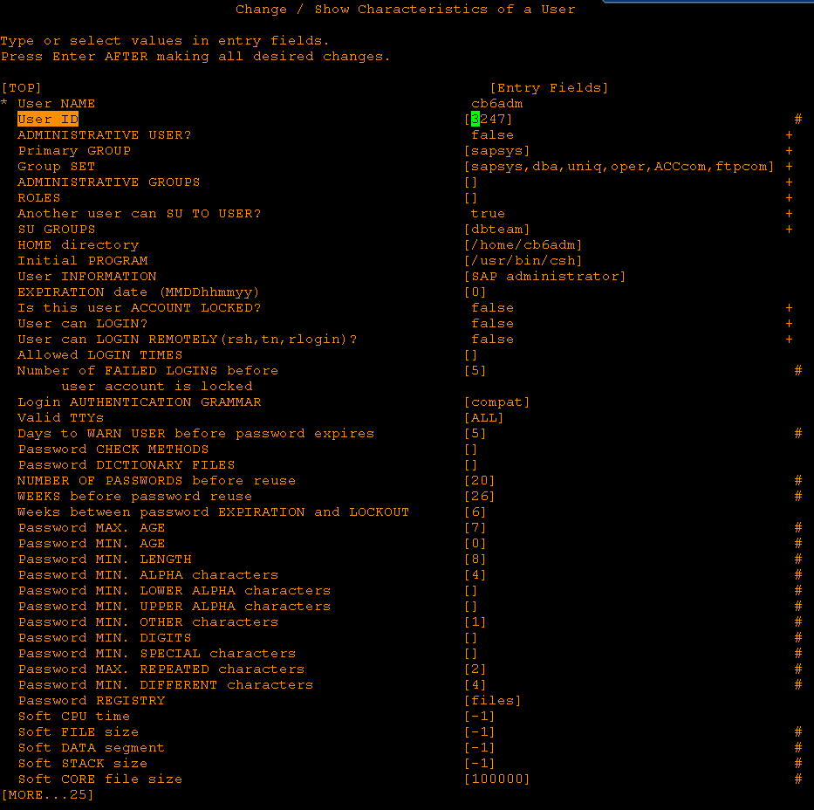

Change the old *sidadm* user home directory name with the new one, and adapt the authorities:



Edit /etc/security/limits:



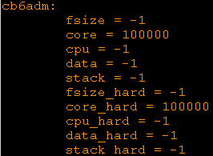

Edit /etc/services:



Then delete the old *sidadm* user:



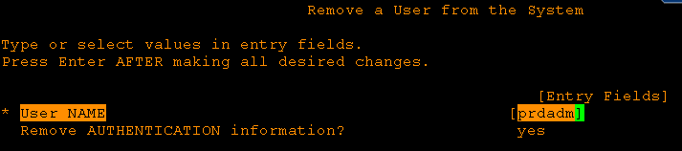

## Filesystems

If needed – Recreate the filesystems to match the PRODUCTION ones.

First make sure there are the same number of LUNs (of same size) mapped to the NEW server than on the PRODUCTION server.

PRODUCTION:

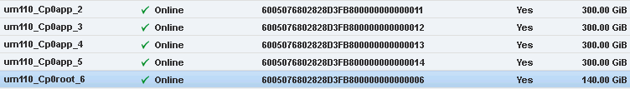

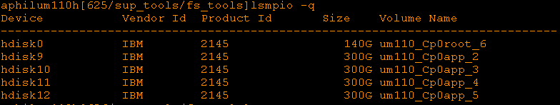

NEW:

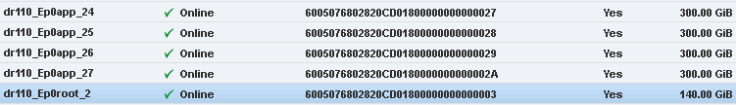

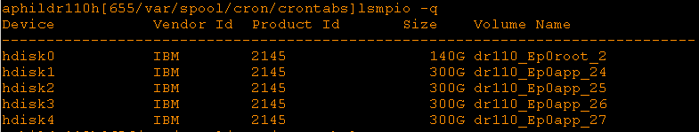

Remove all non-root filesystems from the NEW server for both JFS and JFS2:



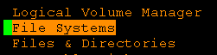



For JFS2:





For JFS:





To get the list of all filesystems to be removed, you can use the following loop:

for vg in `lsvg | grep –v rootvg`

do

lsvg -l $vg | grep –v loglv | grep open

done

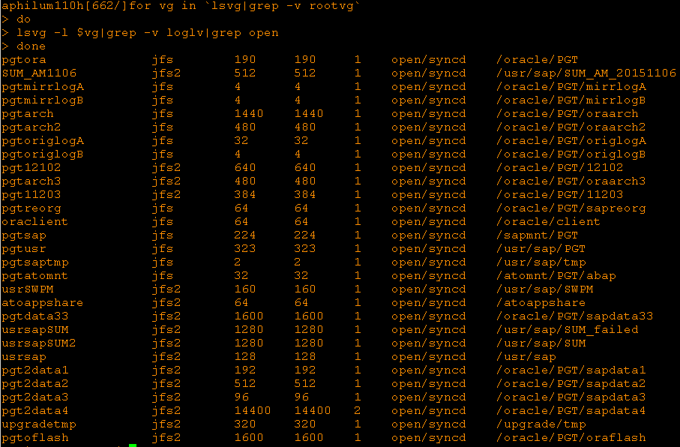

On the NEW server:

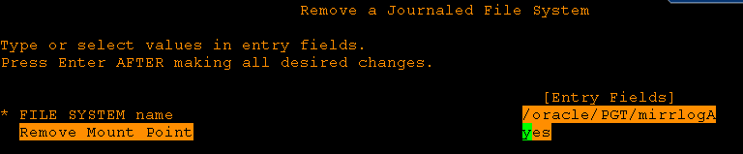

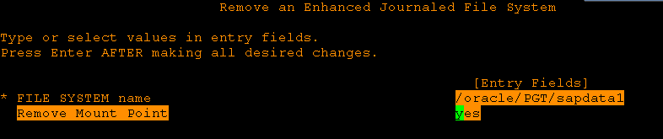

**Etc. – Do the same for all application filesystems.**

Take note of the volume groups on the PRODUCTION server:

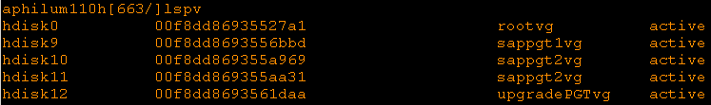

Then recreate the volume groups accordingly on the NEW server:

Make sure you create **scalable** VGs







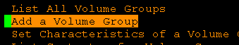



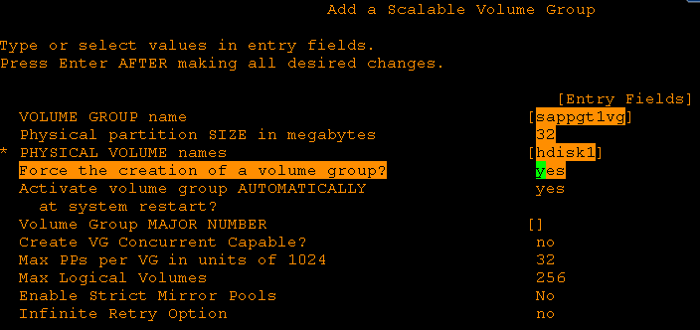

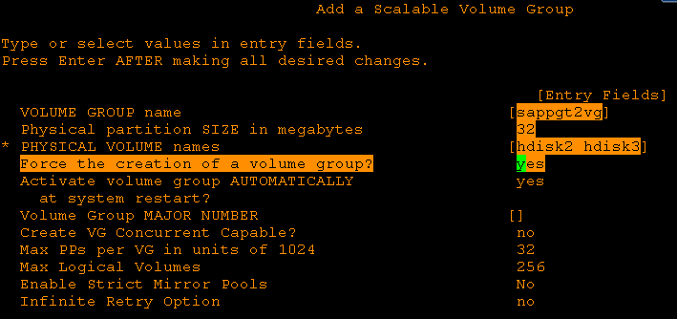

**Etc. – Do the same for all application volume groups.**

Verify that the volume groups are now configured the same way on the NEW server:

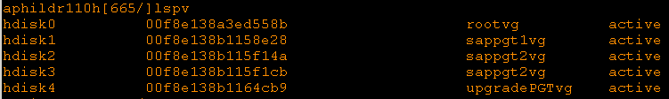

Review – and edit if needed – the .data files to avoid any over mounting issue:

For example /oracle/PGT should be mounted before /oracle/PGT/oraarch

Also, for a new server build, it would be required to change the SID in the filesystems name, but in the case of a DR environment rebuild, this won’t be necessary as the SID would remain the same.

BEFORE:

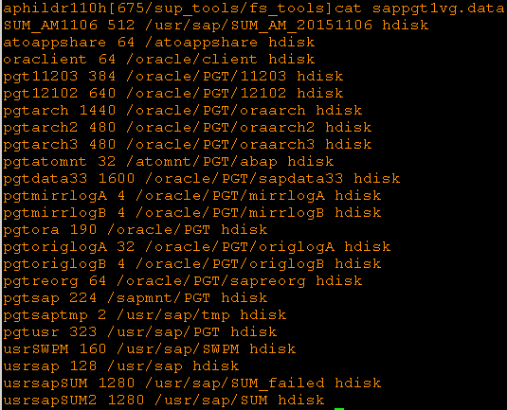

AFTER:9

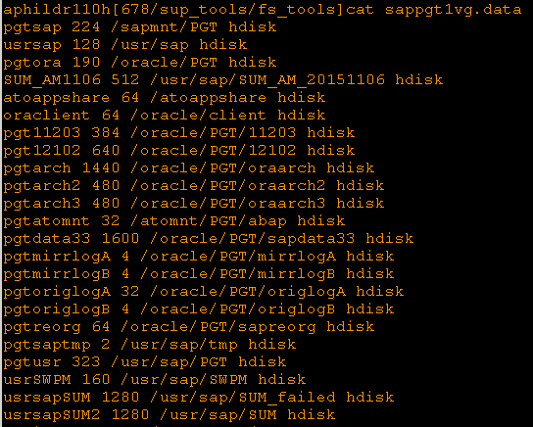

Now, using nohup, we create the filesystems in the right order:

For example, sappgt1vg comes before sappgt2vg



Follow the filesystems creation and look for errors in the nohup.out file:

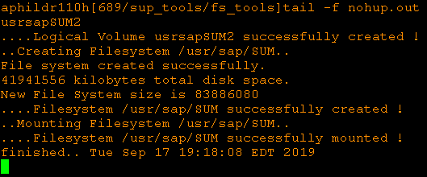

Check the filesystems on the NEW server and compare with PRODUCTION:

PRODUCTION:

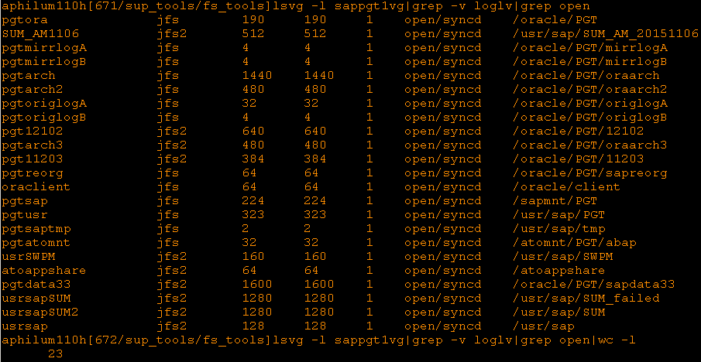

NEW:

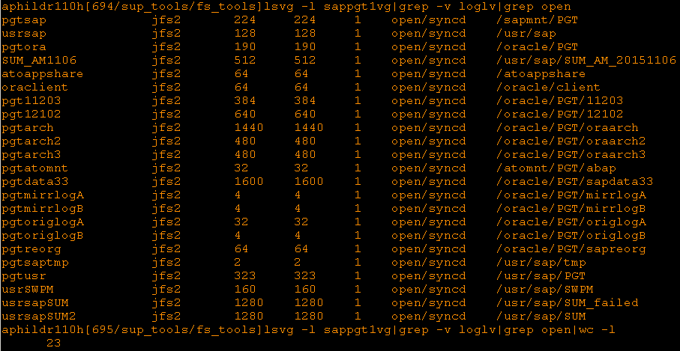

**Etc. – Do the same to create the filesystems in the other VGs.**

## Scripts

If needed – Recreate the scripts to match the new SID.

Remove everything from the /scripts directory and then copy all scripts from /sup_scripts:



Create all SID specific scripts using create_put.setup_cp.sh:



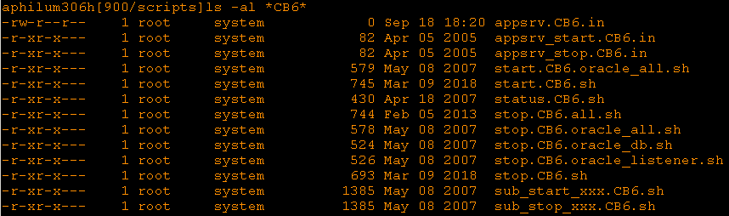

Create all SID specific backup files using create_backup.setup_in.sh:



Edit /scripts/backup.SID.in to keep only the application filesystems and the home directories:

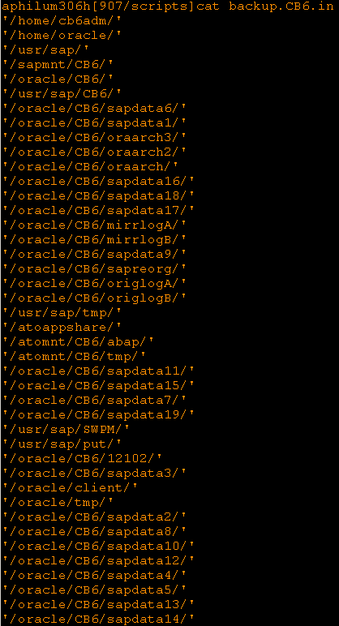

Copy backup.SID.in to backup.SID**BIN**.in and edit it to remove all sapdata, oraarch, mirrolog, origlog and sapreorg filesystems:

